## 5. Wft IT Compliance for Log360

Tagline – Ensure Wft IT compliance with comprehensive log management and monitoring using Log360.

Overview: The Wft IT Compliance extension for Log360 helps financial services organizations maintain compliance with Wft IT requirements. By integrating this extension, IT and security teams gain deep visibility into their IT security and operational controls.
Log360 continuously collects and correlates log data from Active Directory, Windows, Unix/Linux, Microsoft 365, cloud platforms, and network devices, mapping events directly to Wft IT standards. Security teams can track compliance status in real time, investigate incidents quickly, and generate audit-ready reports with a single click.

Key Features:
- Generate comprehensive audit-reports mapped to all Wft IT requirements and financial services controls.
- Aggregates logs from various sources including servers, workstations, network devices, cloud platforms, and applications in real-time.
- Includes threat intelligence integration for identifying malicious activity and compliance violations in logs.
- Export reports in PDF and CSV format for auditors, management, or regulatory submissions.

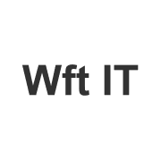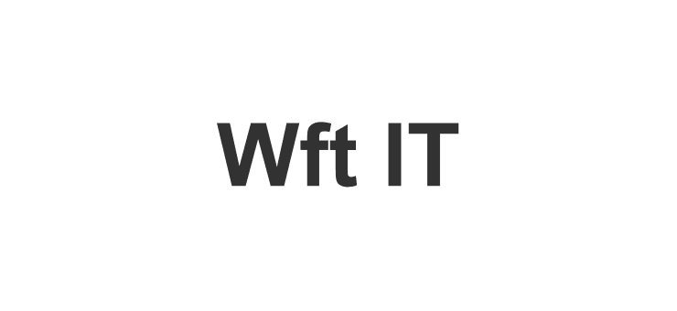

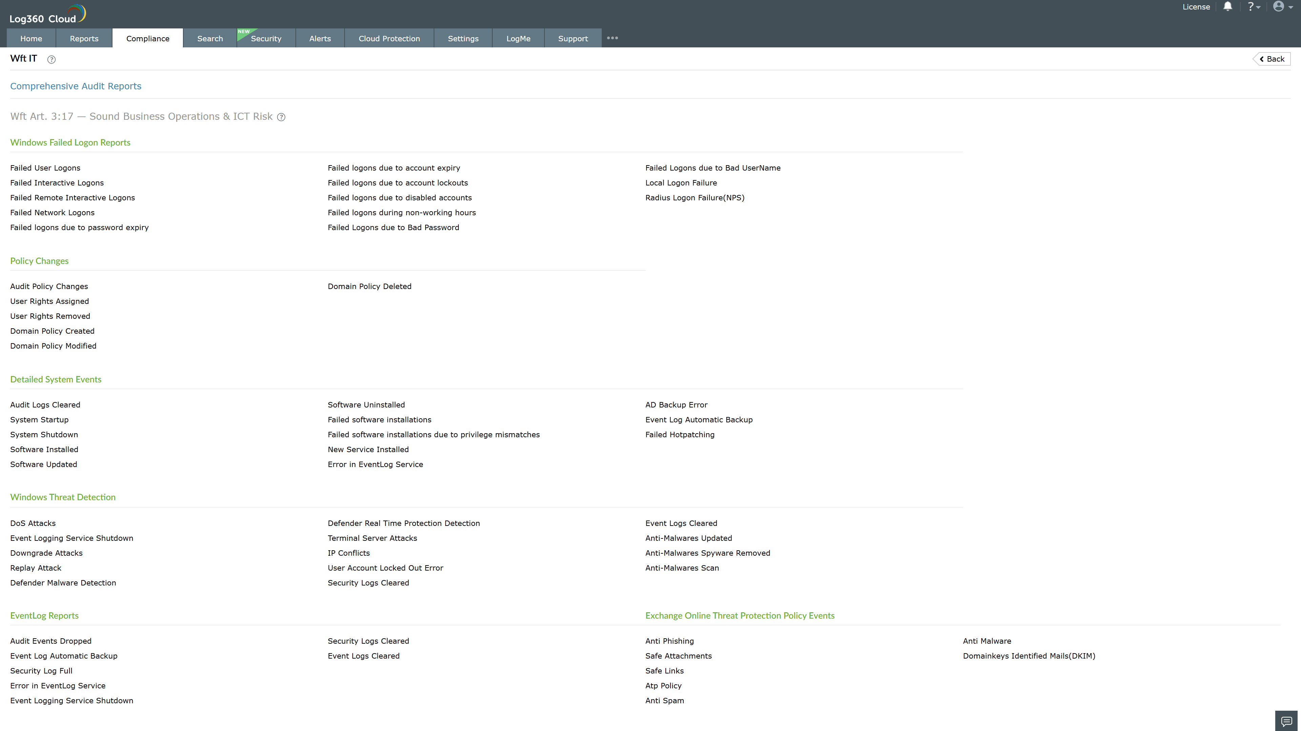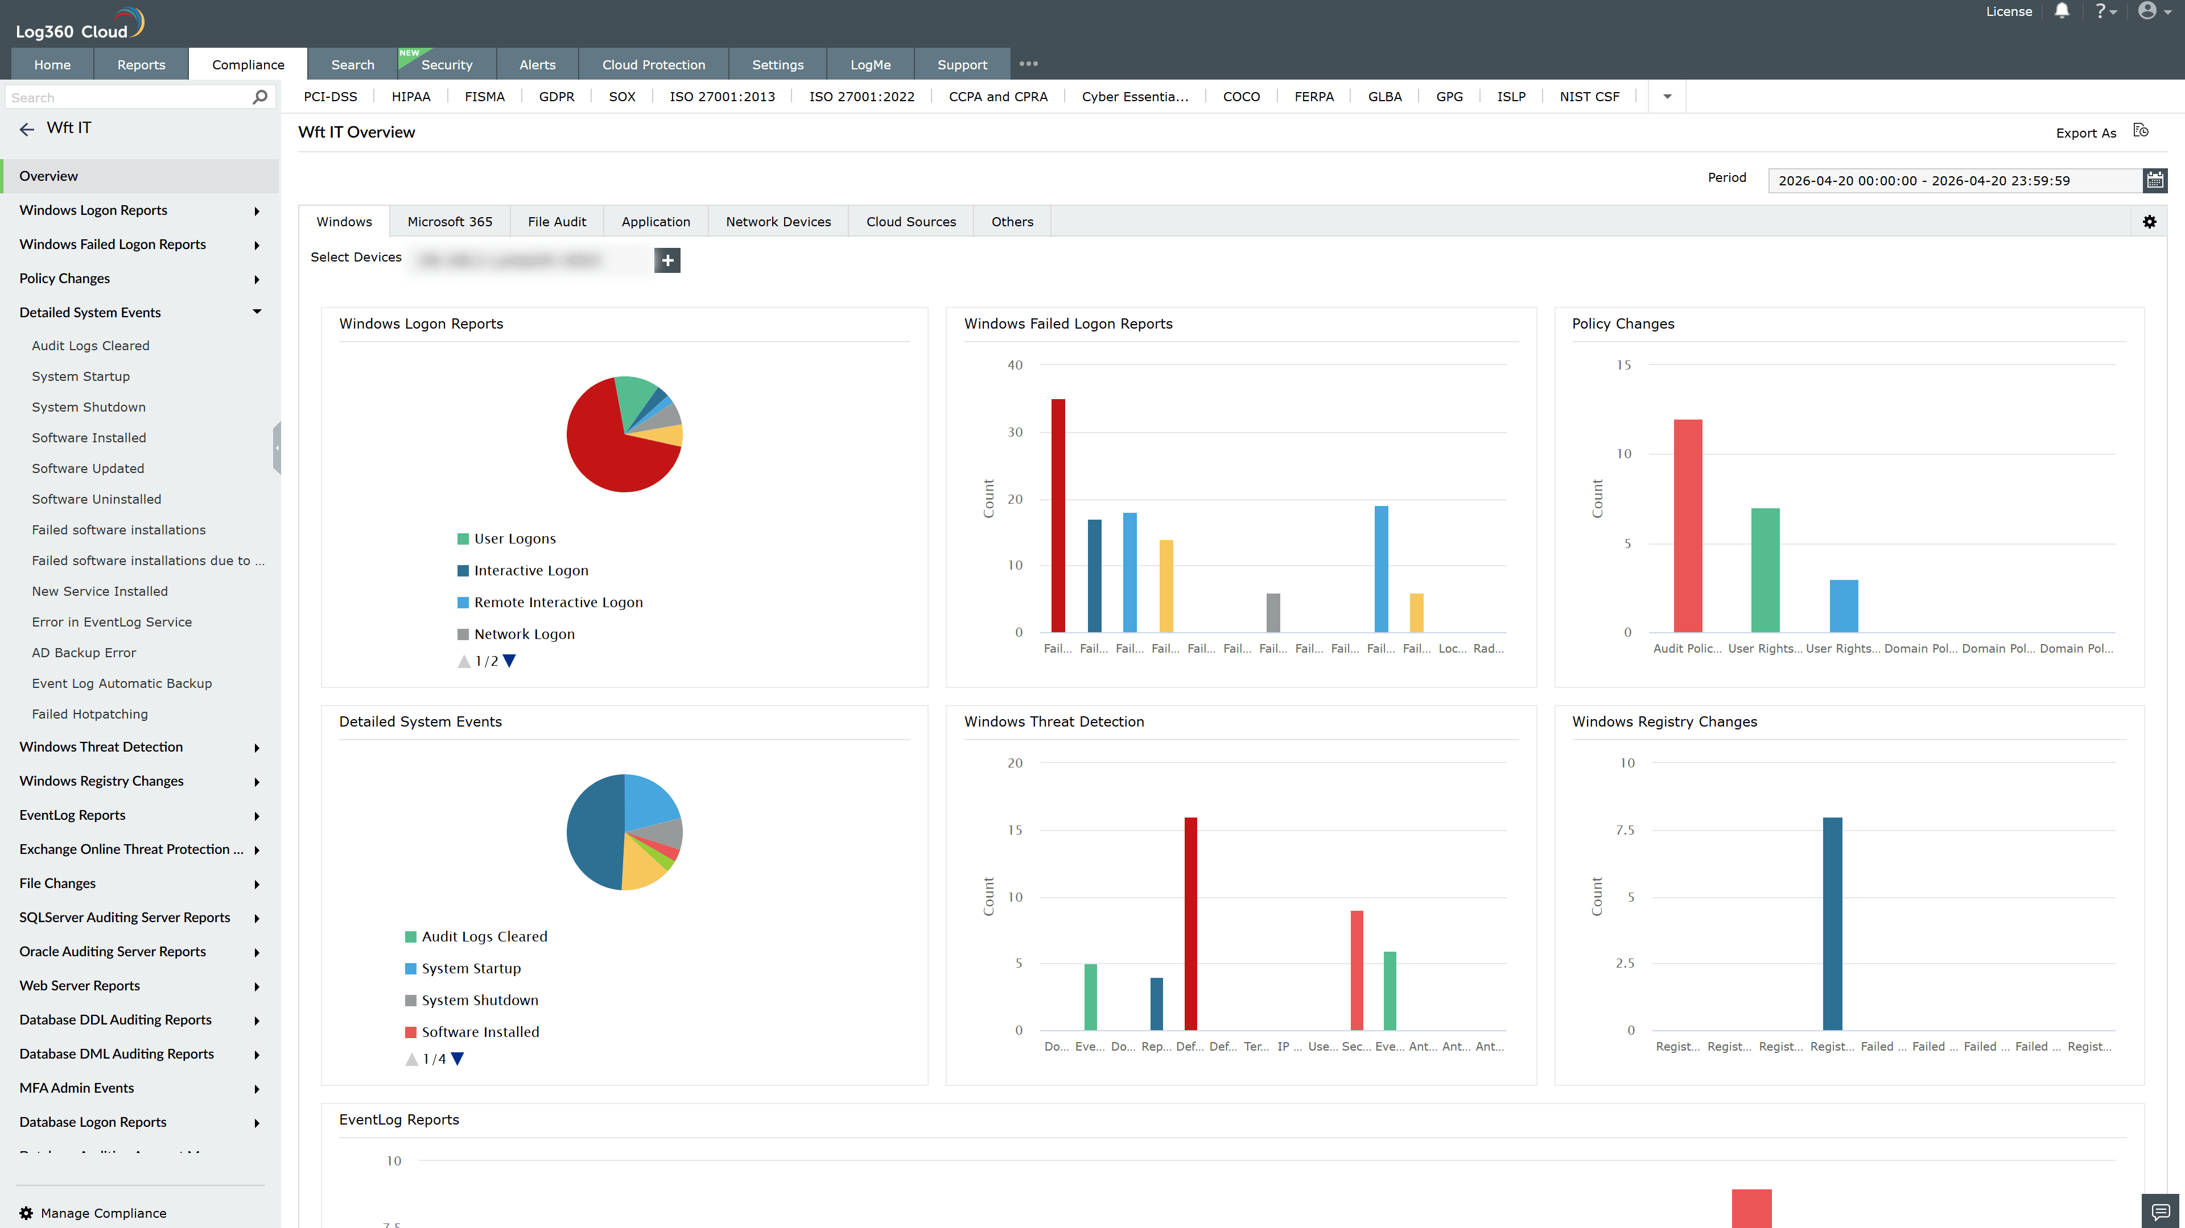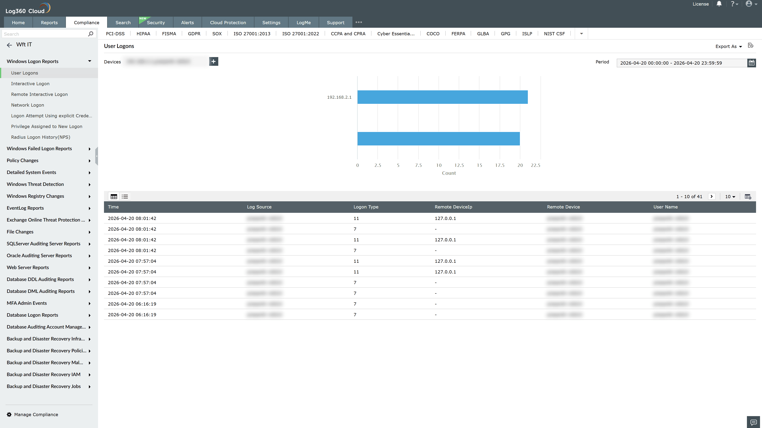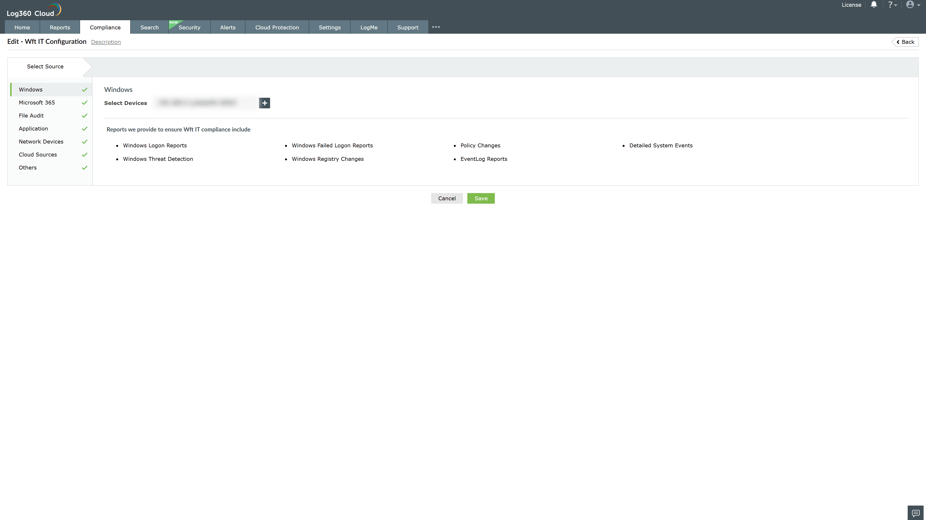

Valid Submission : Yes
Supported Editions : Free, Basic, Standard, Professional, MSSP
Help Document : https://www.manageengine.com/log-management/help/integrations/compliance-extensions.html
Help Video : Not provided
Tags : Log360, Compliance, Privacy monitoring, Data privacy, Regulatory compliance
Supported DCs : US, IN, JP, CA, AU, UK and EU
Privacy Policy:
Terms of Service:
Release Notes:
Predefined reports for the Wft IT Compliance.

